Dr. Anja Hartl
Assistant Professor
University of Innsbruck, Austria
Anja.Hartl@uibk.ac.at

Postdoctoral Research Project (Habilitationsprojekt): The Politics of Shame in the Victorian Novel
Academic Positions
since 03/2023 |  |  | Assistant Professor, Department of English, University of Innsbruck, Austria
10/2019-02/2023 |  |  | Assistant Professor, Department of Literature, Art and Media Studies, University of Konstanz, Germany
10/2015-09/2019 |  |  | Lecturer and Research Assistant, Department of Literature, Art and Media Studies, University of Konstanz, Germany
Education
07/2019 |  |  | Ph.D., English Literature, University of Konstanz, Germany  Title: Experiential Brecht – Dialectical Theatre on the Contemporary British Stage (Grade: summa cum laude)
10/2009-07/2015 |  |  | Teaching Degree (First State Exam), English and French, University of Augsburg, Germany and University of Edinburgh, Scotland
Awards and Fellowships
2022-2023 |  |  | Konstanzia Fellowship, University of Konstanz, Germany
2020 |  |  | PhD Award presented by the city of Konstanz
2016-2019 |  |  | Doctoral Studentship Award, German Academic Scholarship Foundation
2009-2014 |  |  | Scholarship, Max Weber Programme Bavaria
2011-2013 |  |  | Deutschlandstipendium
Organisation of Conferences
02.05.-05.05.2024 | Co-organisation of the 32nd annual CDE conference “Theatre in the Digital Age”, University of Innsbruck (with Univ.-Prof. Dr. Dorothee Birke, Univ.-Prof. Dr. Christopph Singer, Dr. Ulrich Pallua, Ines Gstrein)
08.12.2023 | Co-organisation of the DACH Victorianists online workshop “Victorian Affects” (with Dr. Tim Sommer)
04.-05.11.2022 | Co-organisation of the international conference “Victorian Antipathies”, University of Stuttgart, Germany (with Dr. Nina Engelhardt)
30.09.-2.10.2022 | Co-organisation of the international conference “Liminal Matters: Textures in 19th-Century Material and Literary Cultures”, University of Konstanz, Germany (with Dr. Ariane de Waal)
20.05.2022 | Co-organisation of the workshop “Reading Textures”, University of Tübingen, Germany (with Prof. Dr. Ingrid Hotz-Davies and Prof. Dr. Christoph Reinfandt)
03.07.2018 | Co-organisation of the international symposium “Ethics on Stage”, University of Konstanz, Germany (with Dr. Julia Boll)
Editorial Activities
since 09/2020 |  | Co-editor of the Bloomsbury Methuen Drama Agitations Series (with William C. Boles, Rollins College, USA)
10/2015 – 2020 |  | Assistant to the Review Editor, Journal of Contemporary Drama in English
Peer Reviewer: |  | Springer/Palgrave Macmillan  Bloomsbury  Journal of Contemporary Drama in English (de Gruyter)  Journal for the Study of British Cultures (Winter)
Publications (ORCiD: 0000-0001-9629-3482)
Monograph
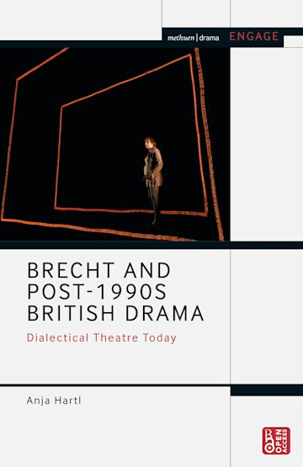
Brecht and Post-1990s British Theatre: Dialectical Drama Today. London: Bloomsbury, 2021. Methuen Drama Engage.
Edition
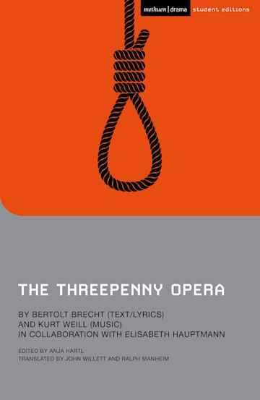
Brecht, Bertolt. The Threepenny Opera. Ed. Anja Hartl. London: Bloomsbury, 2022. Methuen Drama Student Editions.
Articles and Book Chapters
“Adaptation as Border-Crossing Practice in Ali Smith’s Autumn (2016).” Anglistik 34.3 (2023): 141-54.

“Affect in the Theatre-Novel: Performing Shame(lessness) in Wilkie Collins’s No Name.” The Routledge Companion to Theatre-Fiction. Ed. Graham Wolfe. London: Routledge, 2023. 363-76.

“Queering Infrastructures of Romance” (with Jonas Kellermann and Christina Wald). Rethinking Infrastructure Across the Humanities. Eds. Aaron Pinnix et al. Bielefeld: transcript, 2023. 191-200.

“Shakespearean Resonances in Contemporary British Drama: Political and Adaptational Borders in William Shakespeare’s Macbeth and David Greig’s Dunsinane.” Shakespeare Bulletin 41.1 (2023): 63-79.
“History and/as Adaptation: MacBeth and the Rhizomatic Adaptation of History.” Adaptation Before Cinema. Eds. Glenn Jellenik and Lissette Lopez Szwydky-Davis. Basingstoke: Palgrave, 2023. 91-111.
“Brecht, Brexit and Beyond: An Interview with Simon Stephens.” Brecht Yearbook 47 (2022): 6-21.
“Performing the Border in British Politics and Drama: The Case of Scottish Playwright David Greig.” Journal for the Studies of British Cultures 29.1 (2022): 35-51.
“Experiencing Textures: The Materiality of Illegitimacy in Wilkie Collins’s No Name.” Victorian Materialisms, spec. issue of European Journal of English Studies, 26.1 (2022): 105-23.
“Mark Ravenhill’s Dialectical Emotions: ‘In-Yer-Face’ as Post-Brechtian Theatre.” After In-Yer-Face: Remnants of a Theatrical Revolution. Ed. William C. Boles. London: Palgrave, 2020. 71-86.
“Appropriating the Myth of Macbeth in David Greig’s Dunsinane.” Shakespeare Seminar Online 16 (2019): 3-14.
“‘Finstere Zeiten’: Post-brechtsche Dialektik im Werk von Caryl Churchill.” Bertolt Brecht – Zwischen Tradition und Moderne: Studien zu seinem Werk und dessen Rezeption. Ed. Jürgen Hillesheim. Würzburg: Königshausen & Neumann, 2018. 337-57.
“Recycling Brecht in Britain: David Greig‘s The Events as Post-Brechtian Lehrstück.” Recycling Brecht. Eds. Tom Kuhn, David Barnett and Theodore F. Rippey. Rochester, NY: Camden, 2018. 152-69. The Brecht Yearbook/Das Brecht-Jahrbuch 42.
Performance Reviews
“‘Der Stein beginn zu reden‘: Mutter Courage und ihre Kinder am Staatstheater Augsburg.’” Rev. of Mutter Courage und ihre Kinder, by Bertolt Brecht, dir. David Ortmann. ecibs: Communications from the International Brecht Society. 25 June 2024.

Rev. of Was ihr wollt, by William Shakespeare, dir. Anne Mulleners. Shakespeare Bulletin 42.1 (2024): 79-83.
“Alles oder Nichts: Die Tage der Commune am Stadttheater Konstanz.“ Rev. of Die Tage der Commune, by Bertolt Brecht, dir. Johanna Schall. ecibs: Communications of the International Brecht Society 1 (2020).
“‘Staging Contemporary Street Scenes’ – A Workshop by Ann M. Shanahan.” Workshop report. ecibs: Communications of the International Brecht Society 1 (2020).
“‘Musik quillt aus mir’: Baal zwischen Theater und Konzert.” Rev. of Baal, by Bertolt Brecht, dir. Mareike Mikat. ecibs: Communications of the International Brecht Society 1 (2019).
“‘Zur Selbstverständigung’: Bertolt Brechts Der Untergang des Egoisten Johann Fatzer am Theater Augsburg.” Rev. of Der Untergang des Egoisten Johann Fatzer, by Bertolt Brecht, dir. Christian von Treskow. ecibs: Communications of the International Brecht Society 1 (2019).
“Agreement and Disagreement: The Decision at Augsburg's Brecht Festival 2017.” Rev. of The Decision, by Bertolt Brecht, dir. Selçuk Cara. ecibs: Communications of the International Brecht Society 1 (2018).
“‘Nur wer im Wohlstand lebt, lebt angenehm!’: Bertolt Brechts Dreigroschenoper am Schauspielhaus Zürich.” Rev. of Die Dreigroschenoper, by Bertolt Brecht, dir. Tina Lanik. ecibs: Communications of the International Brecht Society 1 (2018).
“War and/as Business: Mother Courage and Her Children in the Age of Terrorism and Globalisation at London’s Southwark Playhouse.” Rev. of Mother Courage and Her Children, by Bertolt Brecht, dir. Hannah Chissick. ecibs: Communications of the International Brecht Society 1 (2018).
“‘There’s Happiness in Doubting’: Brecht's Life of Galileo at London's Young Vic Theatre.” Rev. of Life of Galileo, by Bertolt Brecht, trans. John Willett, dir. Joe Wright. ecibs: Communications of the International Brecht Society 2 (2017).
“A Lesson in Manipulation and an Exercise in Resistance: The Resistible Rise of Arturo Ui at London's Donmar Warehouse.” Rev. of The Resistible Rise of Arturo Ui, by Bertolt Brecht, trans. Bruce Norris, dir. Simon Evans. ecibs: Communications of the International Brecht Society 2 (2017).
“Recycling The Threepenny Opera: Simon Stephens’s New Translation at London’s National Theatre.” Rev. of The Threepenny Opera, by Bertolt Brecht, trans. Simon Stephens, dir. Rufus Norris. ecibs: Communications of the International Brecht Society 1 (2017).
---. Reprinted in Kurt Weill Newsletter 34.2 (2016): 6-7.
Book Reviews
Rev. of Paradoxa über Politik und Theater: Zur Bedeutung der Gegenmeinung bei Denis Diderot und Bertolt Brecht, by Susanne Schmieden. Das Brecht-Jahrbuch 48 (2023): 372-6.
Rev. of A Companion to British-Jewish Theatre since the 1950s, by Jeanette R. Malkin, Eckart Voigts and Sarah Jane Ablett, eds. Germanisch-Romanische Monatsschrift 73.4 (2023): 492-4.
Rev. of Brexit and Beyond: Nation and Identity, by Daniela Keller and Ina Habermann, eds. Zeitschrift für Anglistik und Amerikanistik 70.5 (2022): 467-9.
Rev. of Die Sprache der Infamie III: Literatur und Scham, by Achim Geisenhanslüke. Germanistik 61.1-2 (2020): 148-9.
Rev. of Ecologies of Precarity in Twenty-First Century Theatre: Politics, Affect, Responsibility, by Marissia Fragkou. Journal of Contemporary Drama in English 8.2 (2020): 327-31.
Rev. of The Contemporary Political Play: Rethinking Dramaturgical Structure, by Sarah Grochala. Journal of Contemporary Drama in English 7.1 (2019): 149-153.
Rev. of Anti-War Theatre after Brecht: Dialectical Aesthetics in the Twenty-First Century, by Lara Stevens. Journal of Contemporary Drama in English 6.2 (2018): 363-7.
Rev. of Contemporary Approaches to Adaptation in Theatre, by Kara Reilly, ed. Studies in Theatre and Performance 42.1 (2018): 94-6.
Rev. of Performance in the Twenty-First Century: Theatres of Engagement, by Andy Lavender, and of Not Just a Mirror: Looking for the Political Theatre of Today, by Florian Malzacher, ed. Journal of Contemporary Drama in English 5.2 (2017): 385-91.
Rev. of Die Möglichkeit, dass alles auch ganz anders sein könnte: Geschlechterverfremdungen in zeitgenössischen Theatertexten, by Franziska Bergmann. Journal of Contemporary Drama in English 4.2 (2016): 448-52.

