Extended Abstract Guidelines
- Use this template and delete the instructions text (first page).
- Number of Pages: Up to four A4 pages including text, figures, tables and references. There is no word limit, you can also submit 1 page of abstract.
- Do not include page numbers
- Margins: Each A4 page should have 2.5 cm margins (top, bottom, left and right)
- Font/Style: Title in Calibri Light font, size 18; headings in Calibri Light font, size 16; sub-headings in Calibri (body) font, bold, size 11; main text in Calibri (body) font, size 11. Titles/headings in blue colour, while the sub-headings and main text in black. Affiliations, addresses and corresponding author email in Calibri (body), size 9, italic, black, left indent 1.27cm. Email address is hyperlinked for easy contact. References in Calibri (body) font, size 9, black. All paragraphs followed by one white line space (11 font). All the styles are pre-set in the Styles menu of Word. Headings and subheadings are not numbered.
- AI: We follow the AI recommendations from IWA Publishing: This allows the use of AI tools used within a manuscript, but does not allow for AI-generated content to be used in the place of human authorship. Authors will be held liable for any errors, potential plagiarism or inconsistencies introduced by AI tools. Authorship must be verifiable, which is not possible from an AI tool or content generator. If AI tools are used on an article submitted to IWA Publishing, their use must be clearly explained
- Affiliations and correspondence: Include authors’ names on separate lines, in italics, and indicate the corresponding author with an asterisk (*). Include the address of ALL authors’ affiliations.
- Sections: A recommended structure for the extended Abstract is: Abstract (200 words), Highlights, Introduction, Methodology, Results and Discussion, Conclusion & Future Work, References; If you want you can modify to best fit your research design.
- Review and decision: All extended abstracts will be peer-reviewed, decision on acceptance and on type of presentation (poster or oral) is based on these reviews.
- Correction. After notification you will have the opportunity to revise your extended abstract, which will be published in the conference proceeding. Authors of selected extended abstracts will be invited to submit a full paper to a special issue after the conference
- PDF: All submitted files must be first converted to Adobe pdf prior to submission.

Title

Raina Runoff ¹, Oliver Overflow ¹ ^{2,}* & Urban Ainage²

¹University Innsbruck, Department of Urban Drainage Modelling Conference Organization, Innsbruck, Austria

² UDM Sponsoring Ltd

*Corresponding author email: contact@udm2025.org

Abstract
Write a short abstract with max. 200 words, it is also required to copy this max. 200 word abstract to the submission system.

Highlights
- List up to three key highlights of your paper. Each highlight can be a maximum of one line.
- Be concise and specific. Avoid general statements that are methodologically based.
- You might recognise this template, it’s based on van der Werf (2023)

Introduction
The introduction should present the background/context/motivation for the work conducted and explicitly state the aim of the paper.

Methodology

Subheading 1
Describe the methodology. Keep the description brief whilst highlighting what is new and what could be of interest to others.
The methodology section (and other main sections) can have several sub-sections, each with their own sub-heading (Calibri, font 11, bold). There is no line of space between the paragraph and the heading. In this case, there is also no space between the sub-heading and the main heading “Methods”. All paragraphs have a line of space directly below them.

Subheading 2 - tables and figures
Figures and tables should appear in numerical order, be described in the body of the text and be positioned close to where they are first cited and should not span multiple pages (Table 1). Captions are above the tables, below figures, left-aligned and font size 9. The table and figures themselves should be centre-aligned. Make sure all figures and tables fit inside the text area.

Table 1. This is an example of a table layout. Contents of each cell of tables should be centre-aligned, both horizontally and vertically, except for those in the first column which should only be centre-aligned vertically and left-aligned horizontally. Tables should have horizontal lines and preferably no vertical lines. Table contents can be in font size 9 at a minimum. Make sure to manually change the caption (except the enumeration) to not be bold as per this example.
 | B (mm) | C (m²)
X and X | 123.1 | 1,112
Y and Y | 456.1 | 1,113
Z and Z | 789.5 | 1,114

Case study
Describe the case study /example / data set used to develop, validate and demonstrate the methodology. Keep the description brief with focus on presenting main information.

Results and discussion
Present and discuss the results of methodology application on a case study. Focus on the main outcomes / findings of your paper (Figure 1). It is important that you explain what is new and what could be of interest to others.
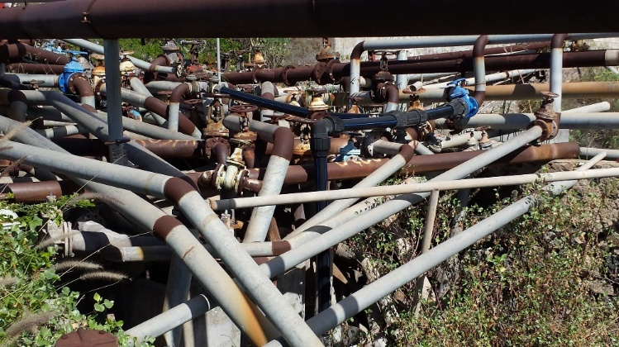
Figure 1. This is an example of a figure of the experimental setup. Centre-aligned. Please ensure all text inside figures is legible; equivalent font 9 size is required. Note this figure occurs directly after the paragraph that first cited it. Again, if using automated captions, you have to manually change the font of the text to not be bold.
For reference citations in text, use surname of author and year of publication: Jones (2002) or (Jones, 2002). Insert initials only if there are two different authors with the same surname and same year of publication. Two or more years in parentheses following an author's name are cited in ascending order of year, and two or more references published in the same year by the same author are differentiated by letters a, b, c, etc. For example: Brown (1999, 2002, 2003a, b). Different references cited together should be in date order and separated by semicolon, for example: (Smith, 1959; Thomson and Jones, 1992; Green, 1999). If a paper has been accepted for publication but has not been published the term "(in press)" should be used instead of a date. If a paper has been submitted but not definitely accepted the term "(submitted)" should be used. The abbreviation "et al." should be used in the text when there are more than two co-authors of a cited paper. Please double-check: every citation in the text must match up to an entry in the reference list and vice-versa. The references should be easily accessible and preferably in English. References must always be given in sufficient detail for the reader to locate the work cited, preferably including either a DOI or a link to the text (see below for formats).

Conclusions and future work
Conclusions should be brief and should highlighting the key points of interest for the readers and any future work that should be conducted. It is a good idea to finish by bulleting out two or three “lessons learned” or findings. We look forward to reading it!

Acknowledgement
We thank Job van der Werf for allowing us to use the template.

References
van der Werf, J (2023). ICUD 2024 Extended Abstract Template, TU Delft
Alcock S. J. and Branston L. (2000). SENSPOL: Sensors for Monitoring Water Pollution from Contaminated Land, Landfills and Sediment. http://www.cranfield.ac.uk/biotech/senspol/ (accessed 22 July 2005)
Bell J. (2002). Treatment of Dye Wastewaters in the Anaerobic Baffled Reactor and Characterisation of the Associated Microbial Populations. PhD thesis, Pollution Research Group, University of Natal, Durban, South Africa.
Henze M., Harremoës P., LaCour Jansen J. and Arvin E. (1995). Wastewater Treatment: Biological and Chemical Processes. Springer, Heidelberg.

