Leopold-Franzens-Universität Innsbruck
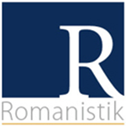  Institut für Romanistik  Innrain 52  6020 Innsbruck | 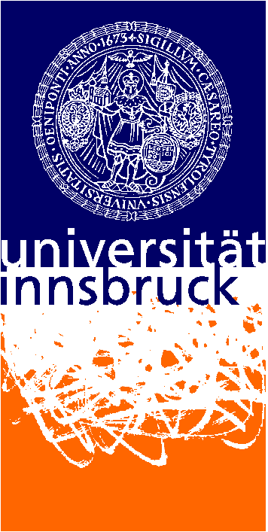 | Frankreich-Schwerpunkt  Herzog-Friedrich-Straße 3  6020 Innsbruck
„Multilingual and multifaceted football“
„Fußball: Mehrsprachigkeit und mehr“
„Le football pluriel et le plurilinguisme“

International Workshop
Fr., 10.6.2016, University of Innsbruck
Claudiana (Herzog-Friedrich-Str. 3)

Organized by: Department of Romance Studies (Univ.-Prof. Dr. Eva Lavric), Frankreich-Schwerpunkt (France Focus), Innsbruck Football Research Group, Project Seminar „Mehrsprachigkeit im Fußball“ (Multilingualism in Football)

Is it true that in football only the legs do the talking? Is this sport really a kind of international language? As popular and tempting as this idea might seem, it is simply wrong because also in football verbal communication and language – rather languages – play an important role. Teams are becoming more and more international, which, of course, raises the question of how communication among players and coaches from all over the world can function successfully. In today’s football world, a new player or coach has no time to gradually become familiar with a new language or culture but he must be operational from the very beginning, which makes it even more surprising that problems and misunderstandings rarely seem to occur and that there are hardly any communication barriers. Which stratgies do clubs develop to cope with multilingualism? Are there language courses, interpreters, private assistants? What does daily life look like for today’s international teams?
Alle these questions are dealt with in this workshop at the University of Innsbruck. The workshop has been jointly organized by Department of Romance Studies, the Frankreich-Schwerpunkt (France Focus) and the Innsbruck Football Research Group. Researchers from many European countries (Austria, Germany, France, Italy, Russia, the Czech Republic) will take part and present their findings, as well as students from the University of Innsbruck who are participating in a project seminar dealing with multilingualism and football. In the evening there will first be a discussion for the general public, where international players, coaches and managers will talk about their experiences with language and communication in connection with football. The evening will then conclude with the opportunity to attend a “public viewing” of the opening game of Euro 2016.

Conference Program:

9:00-11:00
Welcome: Ass.- Prof. Dr. Gerhard Pisek, Dean of Studies (Faculty Humanities 2: Language and Literature)
Univ-.Prof. Dr. Paul Danler, Deputy Head of Department (Romance Studies)

Eva Lavric / Innsbruck Football Research Group (Innsbruck)
„Mehrsprachigkeit im Fußball in Innsbruck 2006-2016“
(Multilingualism in Football in Innsbruck 2006-2016)

Erika Giorgianni (Venice)
„Mehrsprachige und multikulturelle Fußballteams: eine vielstimmige Harmonie?“
Multilingual and multicultural football teams: a polyphonous harmony?

Roman Beljutin (Smolensk)
„Ich habe fertig – Fehlpässe und Metaphorik in der Sportsprache“
„I have finish“ – bad passes and metaphors in the language of sport

11:00-11:15 Coffee break

11:15-13:00
Presentations of students participating in the project seminar “Multilingualism in Football”
Groups “Film/Video” and “Vorarlberg/Markus Ludescher”

Jan Chovanec (Brno, author of the article “Multilingualism in football teams: Methodology of fieldwork”)
“Sports Commentator Talk at Half-Time: Switching from Stylization to Authenticity”

Presentations of students participating in the project seminar “Multilingualism in Football”
Groups “FC Sans Papiers” and “Coaches”

13:00-14:00 Lunch break (buffet lunch organized by students)

14:00-16:00
Presentations of students participating in the project seminar “Multilingualism in Football”
Groups “Referees” and “Football Academies”

Michaela Baur (Lambach /Wels) (author of English for Foreign Premier League Football Players)
“(Sprachliche) Einblicke in Fußball-Nachwuchsakademien der Premier League”
(Linguistic) insights into Premier League football academies

Machteld Meulleman (Reims)
« Le choix de langue dans les interviews et conférences de presse de professionnels de foot étrangers en France: enjeux complexes et stratégies variées »
Language choice in interviews and press conferences of foreign professional football players in France: complex challenges and varied strategies

16:00-16:30 Coffee break

16:30-18:30
Presentations of students participating in the project seminar “Multilingualism in Football”
Groups “Charlie Chaplin/Non-verbal features” und “Bayer 04 Leverkusen”

Uwe Wiemann (Dortmund)
„Deutsch für Ballkünstler – Konzept und Lehrmaterialien zur sprachlichen Integration ausländischer Fußballspieler in deutschsprachigen Profivereinen“
“German for football players” – concept and teaching materials for the linguistic integration of foreign players in professional German football clubs

Georg Spitaler (political scientist, Vienna, author of Foreign Players in Austria)
„Deutsch als „kulturelles Eintrittsticket“? Migration, Transnationalität und Identitätspolitik im österreichischen Fußball“
German as a cultural entrance ticket? Migration, transnationality and identity in Austrian football

19:00 Multilingualism in Football: Discussion Round
Welcome: Vice-Rector Prof. Dr. Bernhard Fügenschuh (University of Innsbruck)
Dr. Franz Pegger (honorary consul, France)

Participants:
Gerhard Stocker (former president, FC Wacker Innsbruck)
Masaki Morass (Austro-Japanese coach, Red Bull Salzburg)
Emmanuel Akwuegbu (coach FC Wacker Innsbruck youth, former player Austrian Bundesliga)

21:00 Public Viewing (France v. Romania)
Public-Viewing-Zone Sparkassenplatz
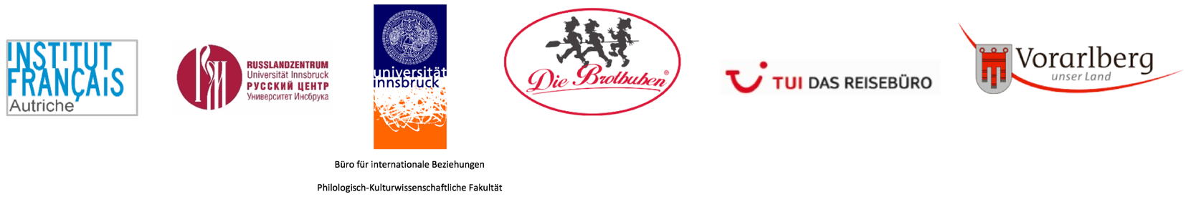
Program sponsored by:

